

**COMPUTER ENGINEERING**

**DS ODD SEM 2021-22/EXPERIMENT 8 NAME:- GAURAV AMARNANI (D7A, 67)**

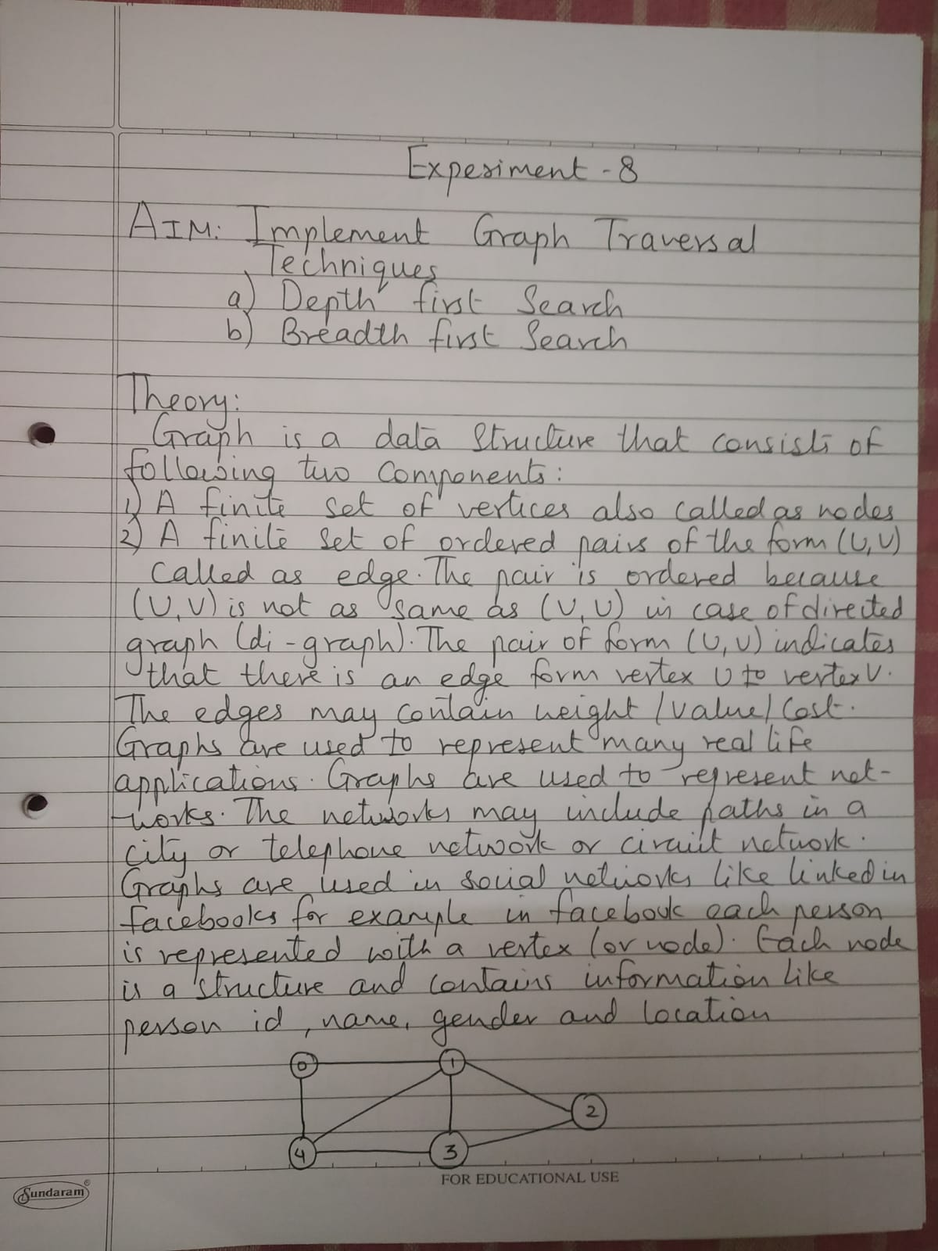

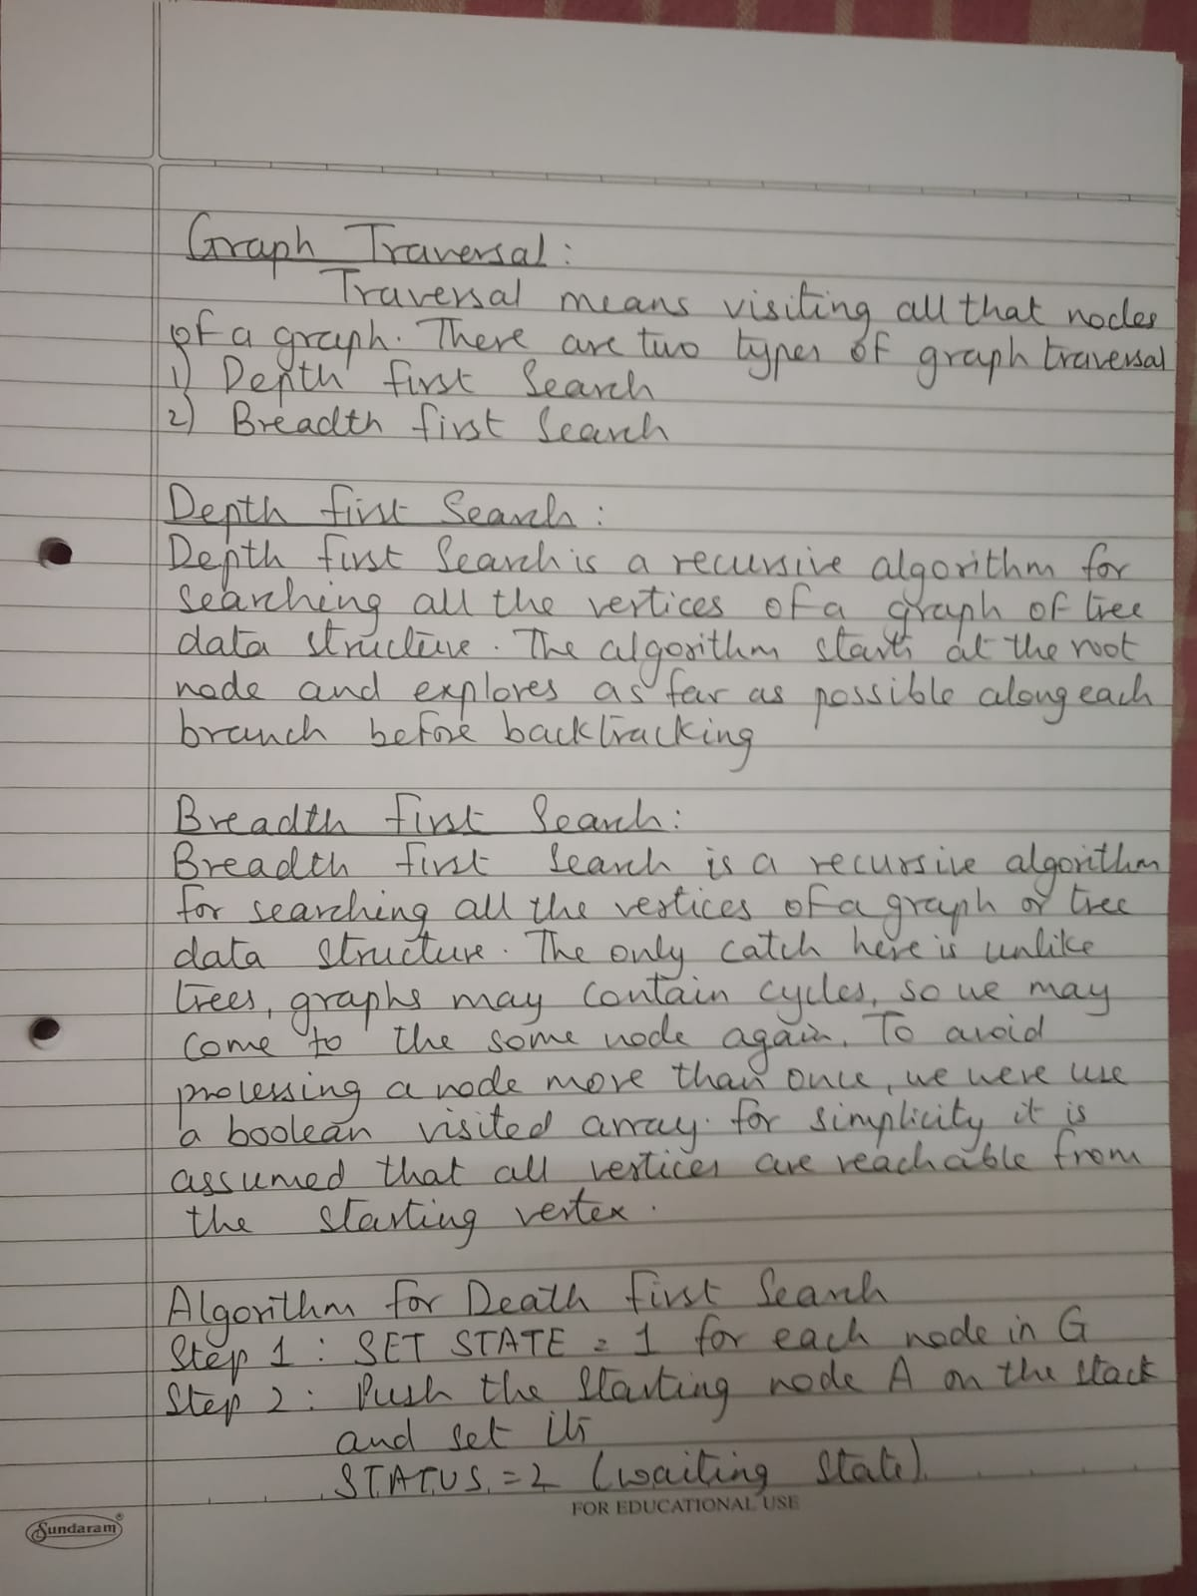

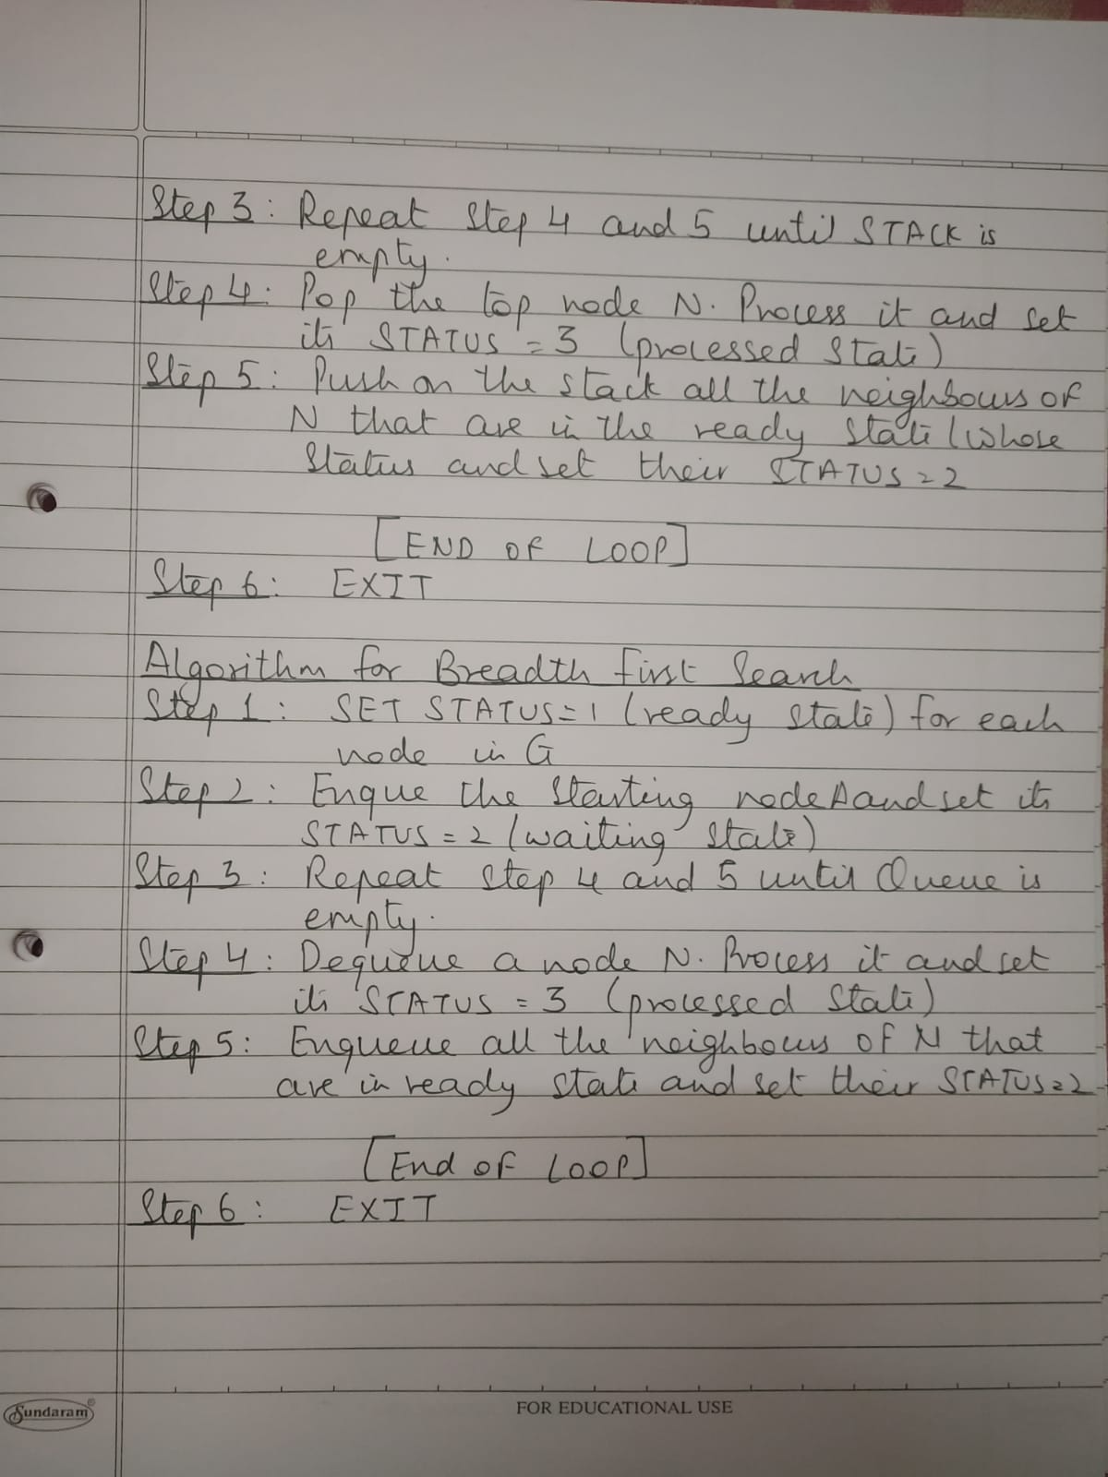



# Depth First Search:

#include<stdio.h> #include<conio.h>

int source, V, E, time, visited[20],G[20][20]; void DFS(int i){

int j; visited[i] = 1;

printf("%d->",i+1); for(j=0;j<V;j++) {

if(G[i][j]==1 && visited[j]==0) DFS(j);

} }

void main(){

int i,j,v1,v2; printf("\t\t\tGraphs\n"); printf("Enter the no of edges:"); scanf("%d",&E);

printf("Enter the no of vertices:"); scanf("%d",&V);

for(i=0; i<V; i++) {

for(j=0; j<V; j++) G[i][j] = 0;

}

for(i=0;i<E;i++) {

printf("Enter the edges(format: V1 V2):"); scanf("%d%d",&v1,&v2);

G[v1-1][v2-1] = 1;

}

for(i=0;i<V;i++) {

for(j=0; j<V; j++) printf("%d",G[i][j]);

printf("\n");

}

printf("Enter the source: ");

scanf("%d",&source); DFS(source-1);

}

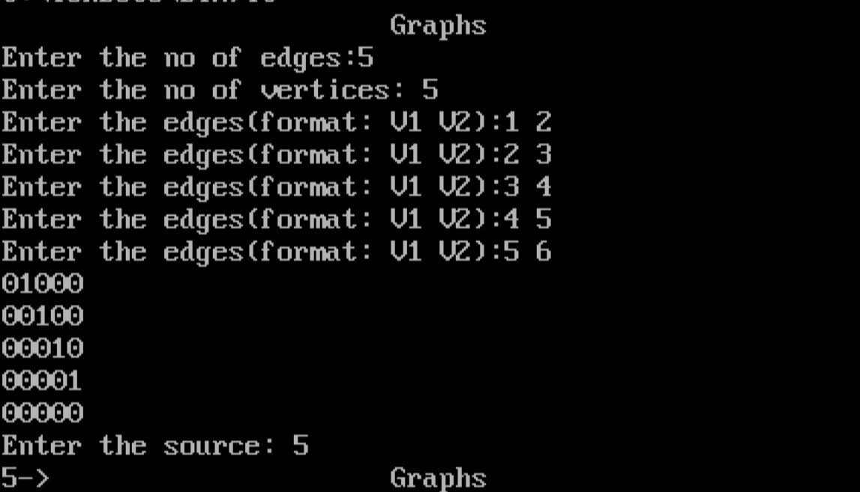

# Breadth First Search:

#include<stdio.h> #include<conio.h>

int a[20][20], q[20], visited[20], n, i, j, f = 0, r = -1; void bfs(int v) {

for(i = 1; i <= n; i++)

if(a[v][i] && !visited[i]) q[++r] = i;

if(f <= r) {

visited[q[f]] = 1;

bfs(q[f++]);

}

}

void main() {

clrscr();

int v;

printf("Enter the number of vertices: "); scanf("%d",&n);

for(i=1; i <= n; i++) { q[i] = 0;

visited[i] = 0;

}

printf("\nEnter graph data in matrix form:\n"); for(i=1; i<=n; i++) {

for(j=1;j<=n;j++) {

scanf("%d", &a[i][j]);

}

}

printf("Enter the starting vertex: "); scanf("%d", &v);

bfs(v);

printf("\nThe node which are reachable are:"); for(i=1; i <= n; i++) {

if(visited[i])

printf(" %d", i);

else {

}

} getch(); }

printf("\nBFS is not possible. All nodes are not reachable!"); break;

